Linked Open Data Development for Sharing the 3D Cultural Artifacts

Weeraphan Chanhom
Pongpon Nilaphruek
weerapan.c@cmu.ac.th, pongpon.pc@gmail.com

Abstract

This paper proposes the prototype of the system for sharing the digital content of cultural artifacts across different sources using Linked Open Data (LOD) and SPARQL protocol service combined with the ontology concept for 3D modeling cultural artifacts in digital museums. In essence, we use an ontology model based on notable museum ontology standards; there are CIDOC Conceptual Reference Model (CIDOC CRM) and CIDOC CRM’s extension is the Conceptual Reference Model Digital (CRMdig) that can annotate all museum content management processes. To make a valuable system, we have implemented data search. The cultural content experts and public entities can seamlessly search digital museum contents and customized high quality 3D cultural object collections to meet their interests.

Keywords- LOD, Ontology, Digital Museums, 3D Cultural Artifacts

I. Introduction
For the situation of cultural heritage areas in Thailand, there are many cultural sources including national and local museums as well as art galleries spread around the country. In order to promote, enable, and share cultural heritage collections by using ICT technology, increase public access for play and learn, and enable scientific study for conservation and restoration in Thailand, a system for distributing cultural information and integrating 3D digital object collections among various museums in a network is highly demanded and this development aims to fill these needs.
The challenge in this project is to solve the data format issue by managing metadata across different resources using LOD technology with museum standard ontology (CIDOC-CRM and CRMdig). This would increase the value of cultural contents by combining the concept of ontology and semantic layers of metadata both in physical object (title, material, state of restoration, etc.) and 3D digital object meaning (file size, angle of lighting, resolution, etc.) and how to conduct them to a single search interface.
This project is developed to support curators, researchers, historians, and public entities to contribute, improve and achieve goals in archiving and sharing the digital content across museums. The prototypes currently host three pilot sites in Thailand; these are Chiang Mai National Museum, Hariphunchai Nation Museum, and Chiang Saen National Museum. Each national museum completed data collection with database but still lacks tools to manage data and content management systems to organize their own resources. The design and implementation of this prototype is proposed to be a shared system to support data from different sources to avoid the consistency problem in sharing data among museums with no data storage limit, and ability to search and retrieve data from other site.

II. Reviews related works
To complete this project, related notable projects and documents in cultural heritage domains have been reviewed as follows:
The Augmented Representation of Cultural Objects (ARCO) project has developed a data model for archiving and viewing the cultural heritage artifacts, the metadata for physical and digital cultural heritage objects were defined. The ARCO system contains three main architectural components an input part for data acquisition, a processing part for management of metadata both of physical and digital contents, and an output part for viewing 3D objects [1].
The MuseumFinland project has developed a portal Website providing cultural artifacts content for achievement of cultural users with semantic concept, which covers an ontological concept in the cultural artifacts domain. In addition, cultural object metadata covering historical sites were combined into the system [2].
The 3DSA project has developed the platform for collecting cultural heritage contents from end users whose semantic annotation services via 3D digital objects that can enable the search, capture, inference, and exchange of cultural heritage knowledge. The highlight of this project is annotations on 3D models and then processing of data to serve for searching and retrieving the content of artifacts [3].
Lightweight Information Describing Objects (LIDO) LIDO is a schema for mapping metadata to ontology of museum contents. The museum standard that they map to is CIDOC CRM and CRMdig for managing the digital contents of a cultural artifact to support curators, which can be accessed offline or online [4].
The European IST Project SCULPTEUR has developed the prototype architecture for managing different metadata formats from different data sources and combined the ontology concept with metadata keyword search focusing on digital content. The important idea of this architecture is the feature for managing the search by properties of 3D objects that can come from 3D editors. They also reuse CIDOC CRM museum ontology standards for the semantic part. And for the part of interoperability they apply Web Service technology for combined resources from each museum [5].
Classical Art Research Online Services (CLAROS) project has developed the system and completed design for combined concept of faceted browser and keyword information search within a single interface [6].
The CIDOC CRM is standard ontology in the museum domain. CIDOC Conceptual Reference Model (CRM) focuses on the documentation interests of museums and similar organizations. The main idea of this standard ontology is for exchanging knowledge of cultural heritage fields across museums at the international level. The relation of the main concept is event, object, place, person, and time [7].
CRMdig Conceptual Reference Model in Digital form is the ontology schema extended from the CIDOC CRM focus on digital contents that related to physical contents. CRMdig is important for explaining and sharing information of cultural heritage in the digital world context [8].

III. Proposed System Achitecture

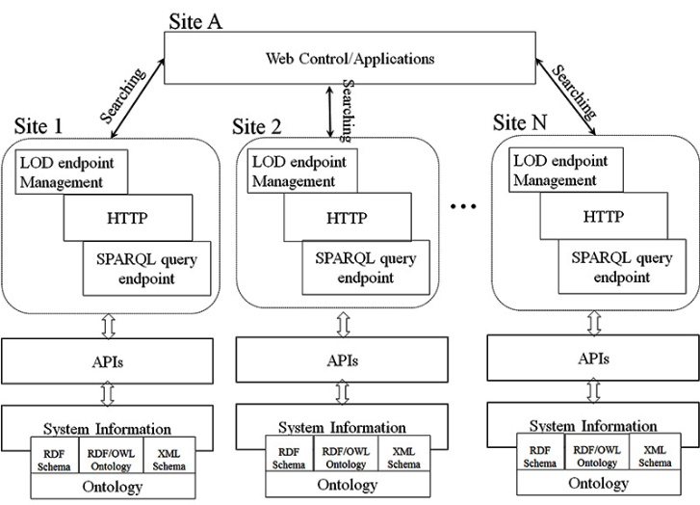

Fig. 1 LOD endpoint extract from LOD: Linked Open Data

Fig 1 shows LOD endpoint overview, every proposed site has LOD endpoint management system to share and query information from other sites. The following is the description of LOD in this paper.
First, the providing sites (in this case, they are site 1, 2, … N) must prepare their SPARQL endpoint as an URL link. It is a SPARQL protocol service, which listens for requests being generally known as a SPARQL endpoint. This channel can be called from any site.
Second, the caller site (in this case, it is the site A) queries desired information via HTTP [9] by using SPARQL query from every sharing site. The SPARQL query will be sent to SPARQL endpoint in each providing site. Fig 2 shows the example method using proposed APIs.
Third, providing sites to access and provide the information corresponding to the desired searching from caller via HTTP as well.
Finally, the caller site will get all desired information, which can be represented in any platform. In this paper, the providing and caller sites have the same mechanism that means they can be a providing or caller site at the same time.

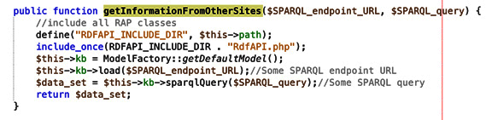
Fig. 2 Pseudo-code of the method for querying information from other sites

IV. Mapping concepts
The schema CIDOC CRM mapping can be synthesized. The physical cultural artifacts is exhibited at the Chiang Mai Nation Museum in Chiang Mai Province, Thailand. In 2016, a digital object (3D model) has been acquired by using a laser scanner developed by Media Arts and Design (CMU) based on a 3D laser technology.
The relation of physical objects and digital objects can describe a hypothetic database, bases on the information where every object is storing and corresponding, in a relation 1:1 to a record structured like:

Physical Object
Title = Buddha Image
Period = 21 Century
Material = Bronze
Place = Chiang Mai National Museum
Person = Mangrai

According to [10], [11], and [12] the example of relation can represent the physical object record in CIDOC CRM as:

Table 1 Physical object metadata map to CIDOC-CRM.
Subject | Predicate | Object
E84.Information_Carrier | P102F.has_title | E35.Title
E18.Physical_Thing | P8i.withessed | E4.Period
E12.Production | P126F.employed | E57.Material
E19.Physical_object | P55.has_current_location | E53.Place
E19.Physical_object | P11.had_participant | E39.Actor

For every physical object, the relation can have many digital objects with the relation 1:M where 1 is the physical object and M is the number of digital objects. For clarity, the following sample data is shown only the information concerning the digital object (3D model) achievements event is following:

Digital Object (3D model)
Author = Media Arts and Design CMU. Team
Rights = Media Arts and Design CMU.
Format_mime = Obj
Device = CNRC scanner
File Size = 700M
Rotation(x,y,z) = 0,0,0
Scale(x,y,z)= 16,16,16
Position(x,y,z)=-6,-214,0

According to [13], the relation can represent the digital object record in CRMdig as:

Table 2 Digital object metadata map to CRMdig.
Subject | Predicate | Object
D2.Digitization_Process | L30.has_operator | E21.Person
D9.Data_Object | P2 .has_type | E55.Type
D2.Digitization_Process | L12F.happened_on_device | D8.Digital_Device
D9.Data_Object | P90F.has_value | E60.Number
D9 Data_Object | has rotation | Base Rotation
D9 Data_Ojbect | has scale | Base scale
D9 Data_Object | has position | Base position
* Base is the adding class to CRMdig

V.The implementation of the prototype website
In this paper, we created the prototype website in order to test and complete the process with focus areas on linked open data in cultural heritage content domains. The prototype websites are developed and setting up in different site/hosting as follows:

www.museumchiangmai.com, www.museumhariphunchai.com, and www.museumchiangsaen.com

Each museum site manages data by themselves and shares information with other museums on their own web site. The result of searching comes from every museum sites that relates user queries, the overall system show as Fig 3.

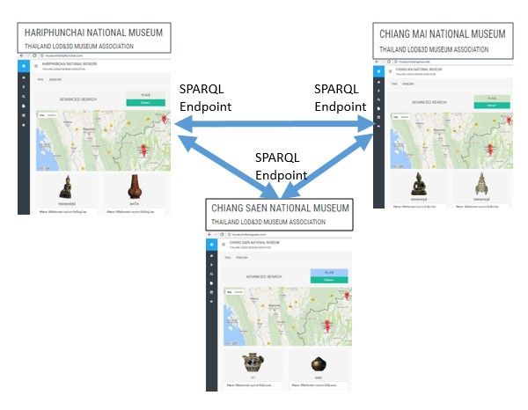
Fig. 3 The system for sharing the digital content of cultural artifacts across different sources using SPARQL Endpoint

Users can access the result with two core interaction concepts, the vertical level-user exploration basic ontology with the concept search and the horizontal level which displays the result set related to the keyword search from the textbox. The information design technique was used for effective display, the results managed by timeline and geographic concept for integrated the result on web browser. Fig 4-6 is the part of the user desktop showing the way users access to the information by ontology concept search, keyword search and the viewing of 3D cultural artifact.
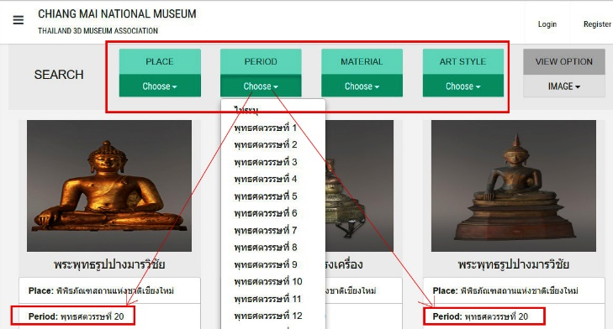
Fig. 4 The result of ontology concept search (http://www.museumchiangmai.com)

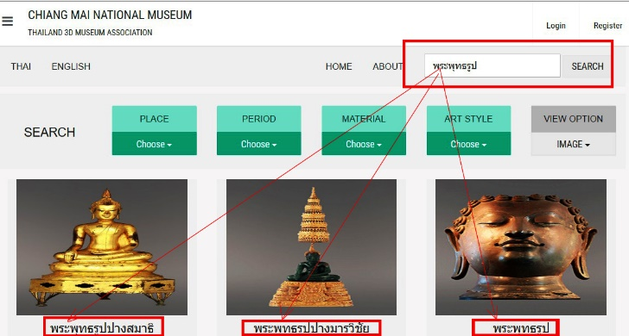
Fig. 5 The result of keyword search
(http://www.museumchiangmai.com)

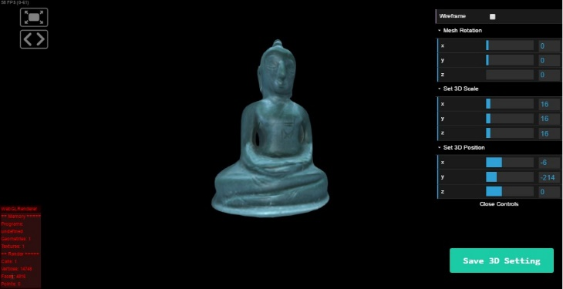
Fig. 6 A cultural artifact with its 3D model.
(http://3dmuseumthailand.com)

VI. Conclusion
This paper presents a implementation of a system to provide effective searching, navigating, and data retrieval of the different sources of cultural artifacts collected by museums with Linked Open Data (LOD), SPARQL service protocol. A proposed system architecture is achieved by combining the ontology, physical object metadata, and digital object metadata based keyword searching and browsing of museum collections, related with physical object and digital object contents.
The case study is currently hosted in three pilot sites in Chiang Mai Province, Lamphun Province, Chiangrai Province, Thailand. In order to archive, preserve, promote cultural artifacts and works of art collected in museums, and galleries, we found mapping physical and digital metadata standard ontology as CIDOC CRM ontology model for semantic annotation of cultural objects within a distributed digital museum network to exchange cultural information in a global environment.
Users can seamlessly search digital cultural object collections by specifying a semantic and intelligent search over the provided user interface which will then automatically integrate relevant cultural objects from different museums in a network. In this way we are moving towards implementation for a framework to dynamic virtual exhibitions and virtual museums based on the proposed ontology and system development as well as apply the reasoning function into the system.

Acknowledgment

The researchers gratefully acknowledge support from Chiang Mai National Museum, Hariphunchai Nation Museum, and Chiang Saen National Museum, Thailand for sharing data. We also want to thank museumthailand.com (Museum Siam, Bangkok, Thailand) and 3Dmuseumthailand.com for being a museum network development.

References

[1] N. Mourkoussis, M. White, M. Patel, J. Chmielewski, and K. Walczak, “Metadata for Cultural Exhibitions using Virtual Reality,” Proc. International Conference on Dublin Core and Metadata Applications, pp.185-193. 2003.
[2] E. Hyvnen, E. Mkel, M. Salminen, A. Valo, K. Viljanen, S. Saarela, and S. Kettula, “MuseumFinland Finnish museums on the semantic web. Web Semantics," Proc. Science, Services and Agents on the World Wide Web, 3(2), pp.224-241, 2005.
[3] 3DSA Portal project, http://3dsa.metadata.net/3dsa/, accessed June. 10. 2016.
[4] Pitzalis, D., Niccolucci, F., Theodoriou, M., & Doerr, M. LIDO and CRM dig from a 3D Cultural Heritage Documentation Perspective. Proceedings VAST 2010, 87–95. (2010). doi:10.2312/VAST/VAST10/087-095
[5] http://www.sculpteurweb.org/html/r&dproject.htm, accessed August. 20. 2017.
[6] http://www.clarosnet.org/XDB/ASP/clarosHome/, accessed August. 20.
2017.
[7] C. Nick, D. Martin, G. Tony, S. Stephen, S. Matthew., Definition of the CIDOC Conceptual Reference Model, Documentation Standards Group, 2008.
[8] http://www.ics.forth.gr/isl/index_main.php?l=e&c=656, accessed January. 24. 2017.
[9] W3C, "Hypertext Transfer Protocol," 2014. [Online]. Available: https://www.w3.org/Protocols/.
[10] M. DOERR, “Mapping of the Dublin Core Metadata Element Set to the CIDOC CRM,” Tech. Rep. 274, ICS-FORTH, July 2000.
[11] BOEUF P. L., SINCLAIR P., MARTINEZ K., LEWIS P., AITKEN G., LAHANIER C.: Using an ontology for interop- erability and browsing of museum, library and archive information. In International Council of Museums 14th Triennial Meet- ing (2005), ICOM COmmittee for Conservation. 3
[12] D. PITZALIS, C. LAHANIER, R. PILLAY, G. AITKEN, A. RUSSELL, D.A. SMITH, P.A.S. SINCLAIR, M.J. ADDIS, R. LOWE, S. HAFEEZ, P.H. LEWIS, K. MARTINEZ, M. C. SCHRAEFEL, “Semantically exposing existing knowledge repositories: a case study in cultural heritage. In The first international conference on Semantics and digital Media Technology,” SAMT, 2006.
[13] 3D-COFORM Integrated Repository Architecture and Design Specifications. http://www.3d-coform.eu/index.php/downloads/ cat view/34-public-deliverables/ 37-repository-infrastructure, accessed June. 10. 2016.

